**Q2.**

**Step 1: After logging into AWS account select EC2 service to create the instance and Name of the server**

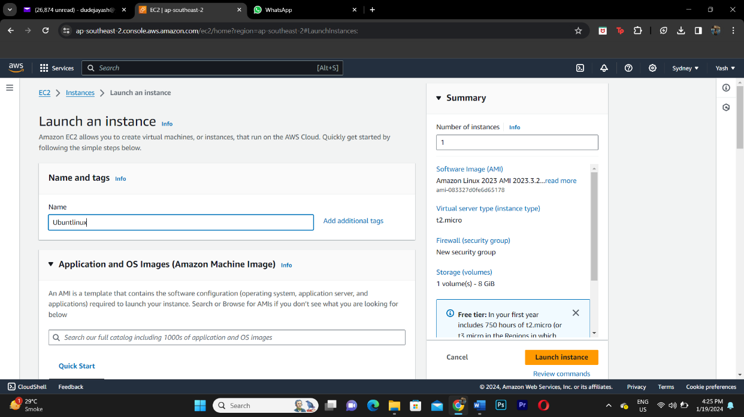

**Step 2: Select the application/OS you want to use**

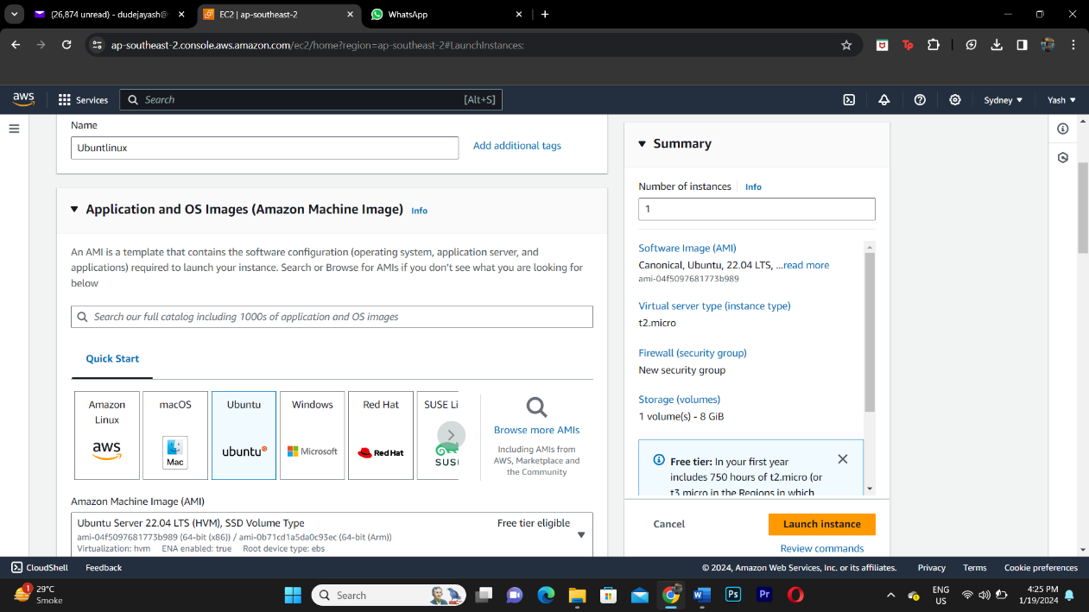

**Step 3: Create a new key pair value**

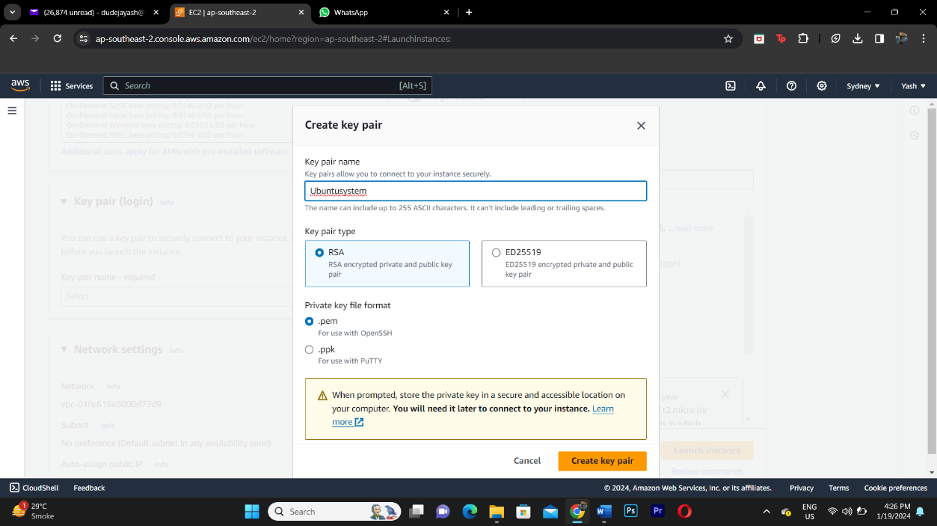

**Step 4: Launch the instance**

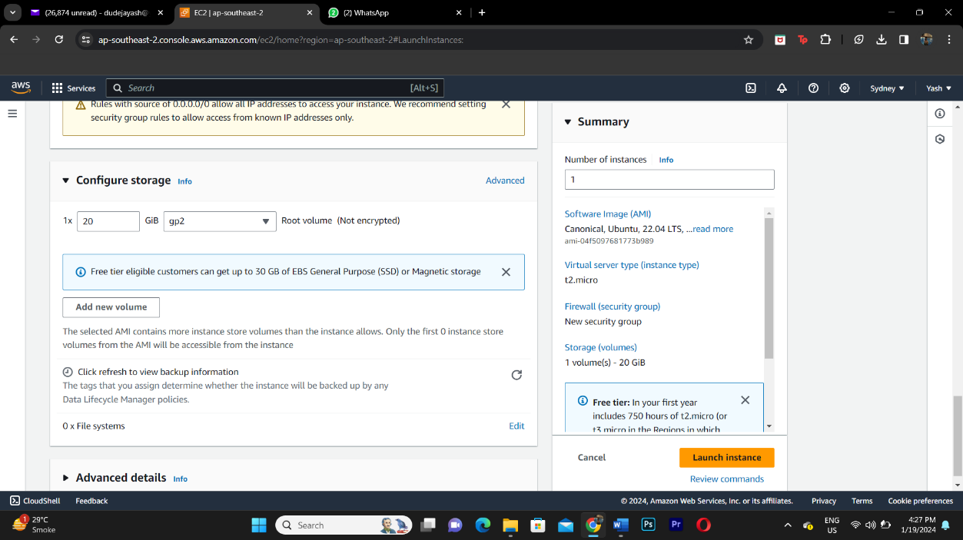

**Step 5: Instance is created**

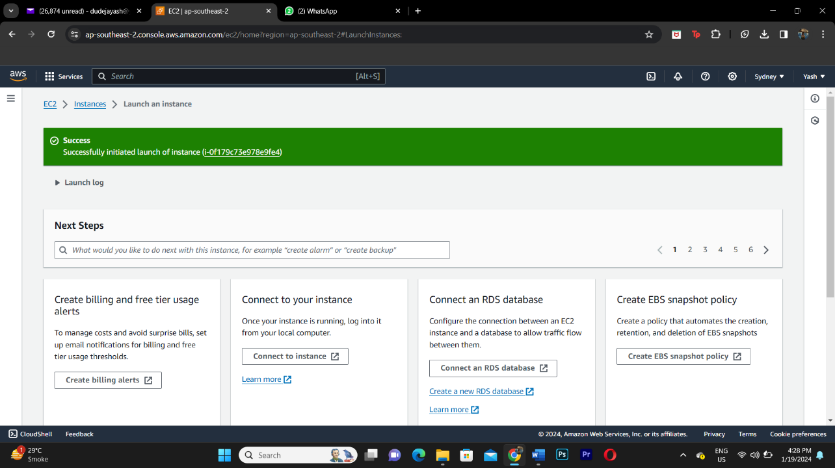

**Step 6: Select the instance and click on connect**

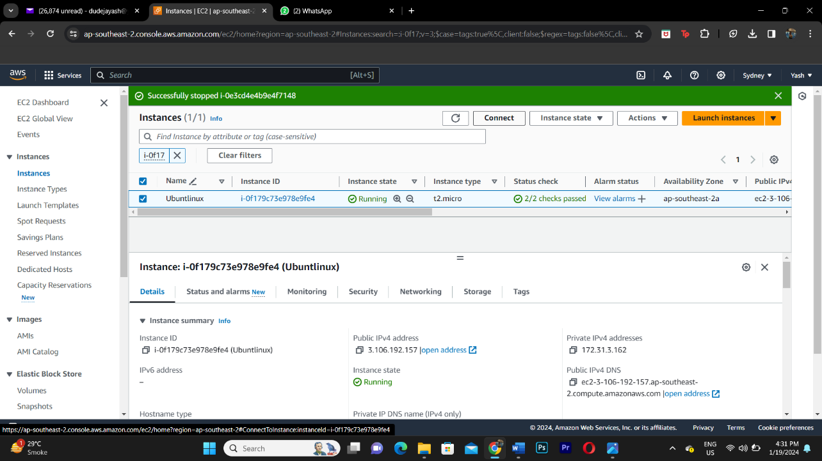

**Step 7: Disk Inforation**

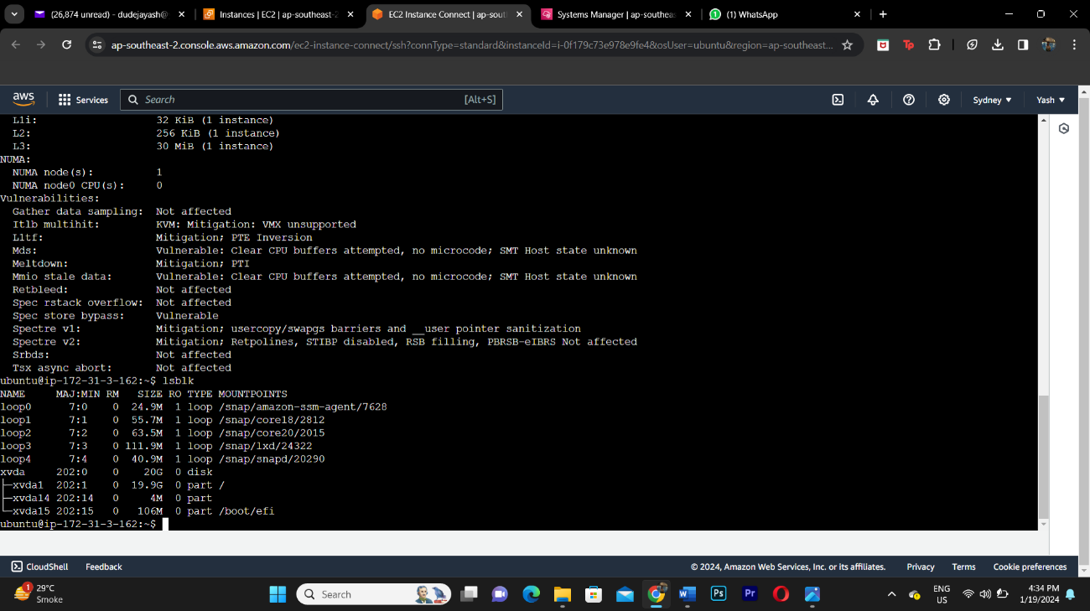

**Step 8: make a directory**

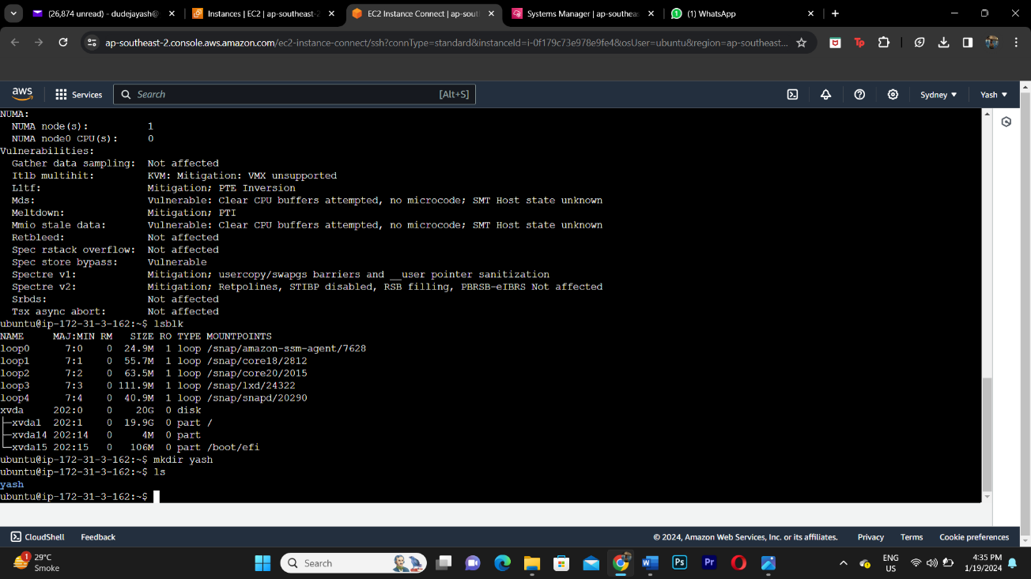

**Step 9: Create a file with your city name and add address to it and ten copy the same into another text file**

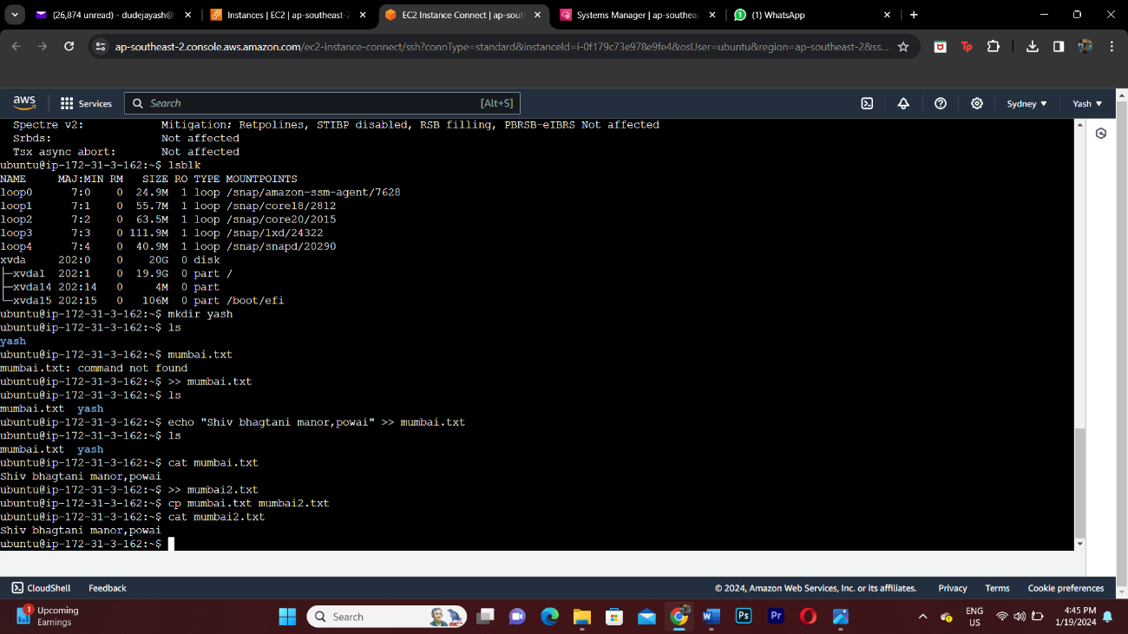

**Step 10: Installing Python**

